Thinkful: Career planning document

This document will collect and organize your work in the career planning lesson of the prep course. Complete each section after reviewing the relevant assignment in the course material.

## Section 1: Explore the landscape

*Write your one to three paragraph reflections for assignment 4.1.1 here.*

Before starting the course, I took the data science radar survey and these are my results: https://www.mango-solutions.com/radar/

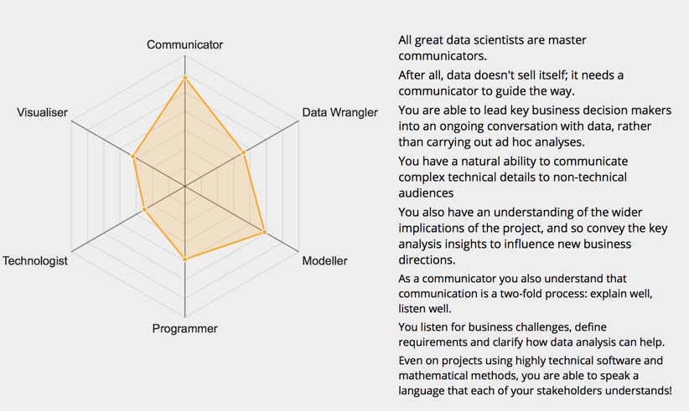

## Section 2: Job postings

*Find five job postings you're very interested in and post them here. Focus on one city. Don't just post the links; job postings have a way of disappearing after a while.*

### Job 1

* + Company name: Stemtech
  + Title: Data Scientist
  + Why did you choose this job? Healthcare
  + Link: https://www.linkedin.com/jobs/search/?currentJobId=834316079&f_E=2&keywords=data%20scientist&location=Georgia&locationId=STATES.us.ga

We are looking for a data scientist that will help us discover the information hidden in vast amounts of data, and help us make smarter decisions to deliver even better products. Your primary focus will be in applying data mining techniques, doing statistical analysis, and building high quality prediction systems integrated with our products.

1. Selecting features, building and optimizing classifiers using machine learning techniques
2. Data mining using state-of-the-art methods
3. Extending company’s data with third party sources of information when needed
4. Enhancing data collection procedures to include information that is relevant for building analytic systems
5. Processing, cleansing, and verifying the integrity of data used for analysis
6. Doing ad-hoc analysis and presenting results in a clear manner
7. Creating automated anomaly detection systems and constant tracking of its performance

### Job 2

* + Company name: eVestment
  + Title: Data Scientist
  + Why did you choose this job? Predictive modeling.
  + Link: https://www.linkedin.com/jobs/search/?currentJobId=815071833&f_E=2&keywords=data%20scientist&location=Georgia&locationId=STATES.us.ga

We are looking for a **Data Scientist** to join our expanding Data Science practice.  
  
We are looking for a Data Scientist to analyze large amounts of raw data to find patterns, fix problems and deliver new insights to take eVestment’s data and solutions to the next level. We will rely on you to work closely with stakeholders across the organization to build data products to extract valuable business insights.  
  
The successful candidate for this role will have strong experience in data analysis, data manipulation, complex problem solving and predictive analytics. As a senior member of the Data Science practice, this person will be called upon to help develop best practices and actively participate in the development of junior team members.

### Job 3

* + Company name: Find Employment
  + Title: Data Scientist – Machine Learning
  + Why did you choose this job? Machine learning. Predictive modeling.
  + Link: https://www.linkedin.com/jobs/search/?currentJobId=834018366&f_E=2&keywords=data%20scientist&location=Georgia&locationId=STATES.us.ga

Exciting opportunity for a Data Scientist to join a cutting-edge software company utilizing the latest cloud and open source technologies!  
  
As the Data Scientist, your primary focus will be in applying data mining techniques, performing statistical analysis, deep learning, and building high quality prediction systems that are integrated with our products. You will also automate scoring using machine learning techniques, build recommendation systems, and develop internal A/B testing procedures. This is a great opportunity to join an innovative and energetic team where you will be a key contributor in developing analysis tools which will influence both our products and clients.

### Job 4

* + Company name: StrategyWise
  + Title: Data Scientist
  + Why did you choose this job? Machine learning, AI, Big Data.
  + Link: https://www.indeed.com/viewjob?jk=6e5dcb04080fd1c4&q=data+scientist&l=30075&tk=1cm0b6leiah4rd0f&from=web&vjs=3

StrategyWise is a global provider of data science and artificial intelligence solutions.

We are seeking a Data Scientist with Machine Learning and AI experience. Candidates who are an excellent fit for this job possess a combination of business acumen, analytical problem-solving skills, programming andstatistical computing, and are adept at learning new skills and grasping complex concepts. This position will challenge you mentally. If you are willing to go the extra mile, learn new skills and completely dedicate yourself to the data science craft, this job is for you. If you want to be on the cutting edge of machine learning, big data and artificial intelligence, and you are willing to invest in yourself and our team, you will find this position immensely rewarding. You will work closely with clients, data scientists, project managers and IT engineers to transform data into knowledge that can be used to make sound organizational, strategic, product, and business decisions.

**Responsibilities**: **(**Reasonable accommodations may be made to enable individuals with disabilities to perform the essential functions)

* Interfacing with client stakeholders to accurately understand and define business challenges and requirements and translate them into analytical solutions
* Extracting, exploring, and wrangling data from various sources/formats to appropriately prepare data for further analyses
* Applying business-relevant statistical, machine learning, or deep learning approaches to solve business challenges
* Programming data science applications that directly solve business challenge, considering infrastructure and end-use constraints
* Consulting on and assisting with deployment of end-to-end data science applications
* Collaborating with StrategyWise team members to learn and share data science best practices

### Job 5

* + Company name:
  + Title:
  + Why did you choose this job?
  + Link:

## Section 3: Your company hitlist

*Find five dream companies (whether or not they're hiring data scientists right now) and add them to this hit list. Focus on the same city you did for job postings. Include a sentence about why you added each company.*

### Company 1

* + Company name: Federal Government
  + Why did you choose this company? Help solve public issues such as health, security, and economics.

### Company 2

* + Company name: Georgia Government
  + Why did you choose this company? Help solve state issues such as education, crime, budget and investment.

### Company 3

* + Company name: IBM
  + Why did you choose this company? Broad opportunities and consulting.

### Company 4

* + Company name:
  + Why did you choose this company?

### Company 5

* + Company name:
  + Why did you choose this company?

## Section 4: Find your people

*Add the data science related events in your area and find LinkedIn profiles for local data scientists working at the kind of job you want.*

### Local data science events:

* Google Cloud + SoftServe Meet-up: Machine Learning Design, Demystified. 8/29 6pm
* The Sports Innovation Challenge Presented by Georgia Tech Athletics. 11/3. 3pm
* ATL Homegrown: Demo & Drinks. 9/13. 6-8:30pm

### Local data scientist from a company on your hit list:

### First or second degree connection in the industry:

## Section 5: Write your own story

*Make the work you've done so far concrete.*

### Hi I'm David.

### I'm looking for career opportunities in data science, particularly predictive modeling.

### I recently completed an immersive data science boot camp. Where I sharpened my skills in Python, R, visualization, data modeling, and machine learning.

### Prior to this I have 10 years’ experience working with data - for software as a service implementation. Primarily HR/Benefits space. I did lots of data wrangling and data migration - to onboard new clients and interface with vendors and partners.

### I'm making this career pivot to data science - because I'm passionate about discovering insights and telling compelling stories from data. I'm a curious person. I also have an MBA from Georgia Tech.

### Describe your ideal job to an industry professional

### Describe the same job to a non-technical family member

### Draft your aspirational professional summary